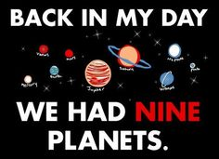
TUG-A-WAR…You decide and take a side!
Essential Question: What evidence justifies that Pluto is a Planet or not?

Why is Pluto Not A Planet? (video)
Neil deGrasse Tyson on “The Big Bang Theory”

Dr. Neil Tyson DeGrasse: Pluto’s Place in the Planet video (1 hr 42 mins)

Why Pluto is No Longer a Planet (video and article)
Dwarf Planet Pluto: Facts About the Icy Former Planet (video and article)
The People Have Voted: Pluto is a Planet! (video and article)

Mark the text while reading each article. Take Cornell Notes of key information (at least half a page per article). Decide which side you are on in the debate. Write one sentence that provides JUSTIFICATION for your viewpoint on the post-it note provided. Use a specific sentence (EVIDENCE) from the article to support your thinking. Post your post-it on the Tug-A-War board in the back of the room.

Article to read (Tug-A-War):
Pluto a Planet Again? It May Happen This Year

Article to read (Tug-A-War): What Is Pluto?

NASA’s New Horizons Spacecraft Begins First Stages of Pluto Encounter

CSI Smart Goal #1: All VMS students will improve their reading comprehension skills.

CSI Smart Goal #2: All VMS students will improve their ability to communicate math ideas by justifying
their claims with evidence.

