Taking Cornell Notes (C-Notes)

Every student will be required to take class notes in the Cornell Format. In class we will learn the appropriate format and use of the notes, though I will summarize their purpose and basics here.

- Purpose and advantages of using the Cornell note-taking system (C-notes)
- C-note-taking is a method for mastering information, not just recording facts.
- C-note taking is efficient.
- Each step of the C-note system prepares the way for the next part of the learning process.

- What is needed to get started?
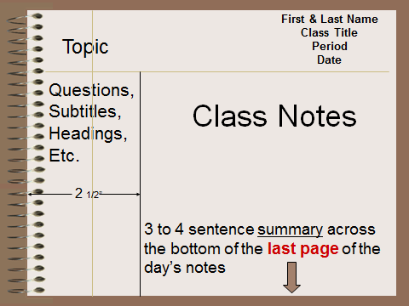
- A clean sheet of paper in the student’s binder, notebook or journal.
- A 2½ -inch column at left side of each page to record main ideas and sample test questions from the lesson.
- A 3-4 line section at bottom of the last page of notes to be used for summary of the main points of the lesson.

- How should notes be recorded?
- During class, record notes to the right of the extended margin
- Strive to get main ideas and examples down. Facts and details are important, but they’re meaningful only alongside concepts.
- Use abbreviations to save time.
- Use graphic organizers or pictures when they are helpful.
- Separate blocks of information logically by skipping lines between them.

- After class, refine notes
- Re-read notes and underline key words and phrases.
- Correct/enhance incomplete items:
- Loose dates, terms, names.
- Notes that are too brief for recall months later.
- Write sample test questions in the left-hand column based on the information on the right.
- Read underlined words and write recall cues in the left-hand column (key works and very brief phrases to help you remember later) *Note: These are in addition to your questions.
- At the bottom of the page, write a summary paragraph about your notes.

- Use Notes as a Study Guide
- Cover up the right side of the page. Read your sample test questions. Recite the information from memory as fully as possible. Uncover your notes and verify information frequently (single, most powerful learning tool!)
- Follow the organization of the lessons for the unit. Study the progression of information to recognize the categories, relationships, main ideas, and connections. Record all of these insights! REFLECTION = THE KEY TO MEMORY!!

