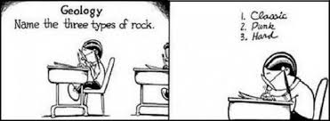
WORD BANK FOR ROCK SONG OR RAP
www.geology.com
Rock Weathering Granite
Erosion Minerals Gneiss
Igneous Sedimentary Metamorphic
Magma Sediment Cementing
Pressure Deposition Lava
Compacting Sandstone Volcano
Heat Melting Mountains
Hardening Cooling Earth
Ocean floor Intrusive rocks Extrusive rock

