Creating Comics
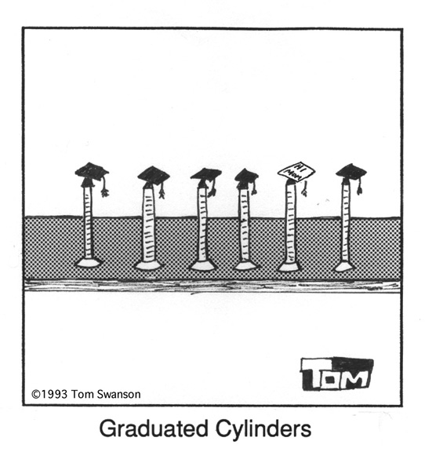

Comic Vocabulary Interactive

Comic Vocabulary Definitions and Examples:
Text Containers

Comic Vocabulary Definitions and Examples: Layout & Design

Comic Vocabulary Definitions and Examples: Angles
Think about the “science” that you want to show in your comic. You may use any topic in science: science processes, equipment used in science, anything that you think represents a “science” concept/idea. Think about plays on words (cheetah---cheater), think about the characteristics of the animal or concept (giraffes have long necks, so they would need a long milk carton), think about comparisons that can be made to humans (tapeworms on vacation---families vacation; where would a tapeworm vacation?). What is the overall message of the cartoon (what “science” is expressed)?
Comic Creator Student Interactive
http://www.readwritethink.org/materials/comic/index.htm

