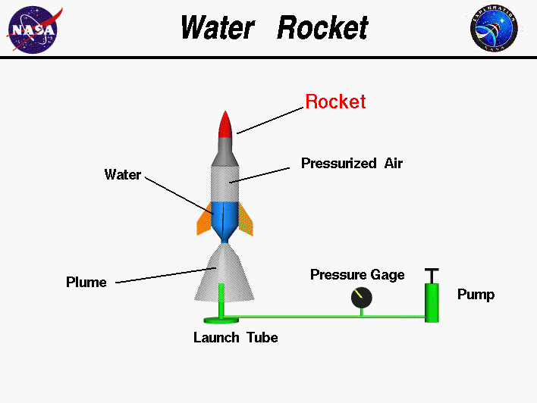
Bottle Rocket Vocabulary
1. Newton’s First Law of Motion –
2. Newton’s Second Law of Motion –
3. Newton’s Third Law of Motion –
4. Inertia –
5. Force –
6. Weight –
7. Thrust –
8. Drag –
9. Friction –
10. Aerodynamic –
11. Velocity –
12. Density –
13. Altitude –
14. Center of Mass –
15. Center of Pressure –
16. Stability –
17. Balanced & Unbalanced Forces -

